# Michael Chillemi

# 06/02/2023

# CS 590 - Algorithms

# M3.B2: Module 3 Binary Search Trees Creativity Exercises

# 

Problem 3.6.17

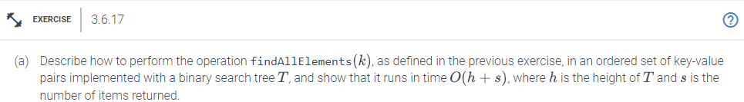

Answer:

In Problem 3.6.17, you must explain how to use a binary search tree to create an ordered set of key-value pairs with the method findAllElements(k). In order to find the solution, one must repeatedly traverse the binary search tree, compare each node's key to the target key k, and, if the keys match, add the node's value to a list of results. FindAllElements(k) has an O(h + s) time complexity, where h is the height of the tree and s denotes the quantity of returned elements.

Problem 4.7.25

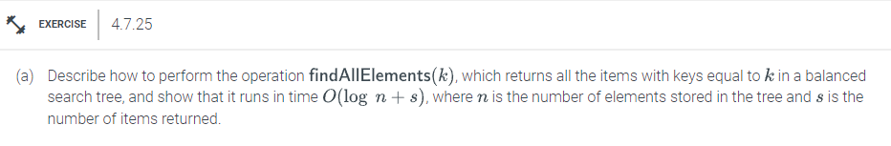

Answer:

The goal of Problem 4.7.25 is to demonstrate how to implement the operation findAllElements(k) in an ordered array of key-value pairs and to demonstrate that it takes O(log n + s) time, where n is the number of elements in the array and s is the number of items returned. The answer entails finding the first element with key k using a modified binary search technique, iterating through the array to gather all elements with the same key, and then solving the problem. Due to the binary search and the time required to gather all matching items, this technique has an O(log n + s) time complexity.